AI ASSISTED CODING
ASSIGNMENT - 9
NAME: P.SAI SHANKAR
HL-NO: 2303A52500 BATCH: 50
Lab 9.5:
Task – 1 : Zero-Shot Prompting – Leap Year Check Scenario Zero-shot prompting involves giving instructions without providing examples.
Prompt : Generate a Python Code that accepts a year as input and checks whether the given year is a leap year.
The function should return an appropriate result indicating whether the year is a leap year or not.
Also include a sample input and its corresponding output.
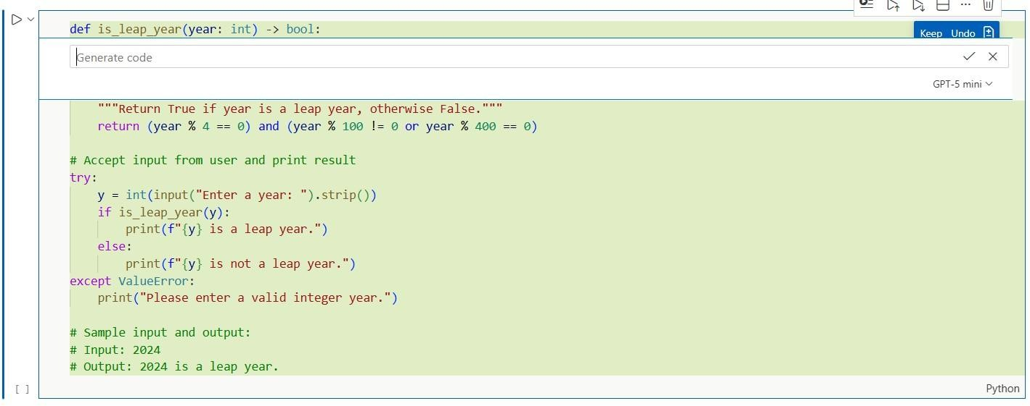
Output-
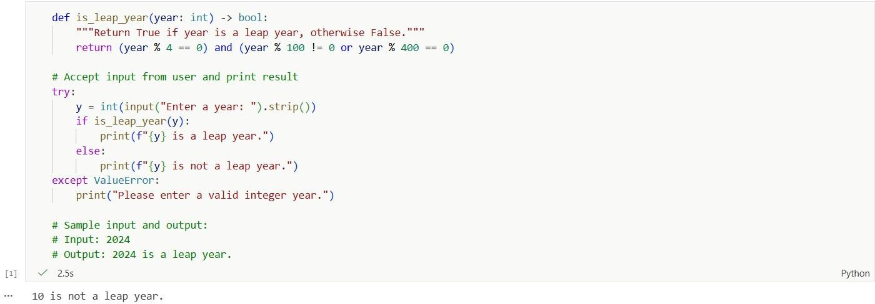

Task – 2 : One-Shot Prompting – Centimeters to Inches Conversion Scenario
One-shot prompting guides AI using a single example. Prompt :Convert centimeters to inches using Python.
Example:
Input: 10 cm
Output: 3.94 inches
Now generate a Python code that:
- Accepts a value in centimeters as input
- Converts it to inches using the correct formula
- Returns the converted value

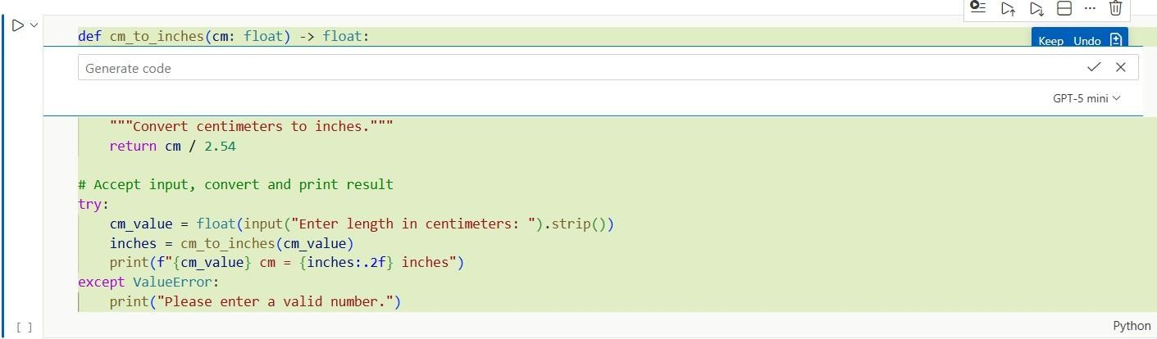

Output -
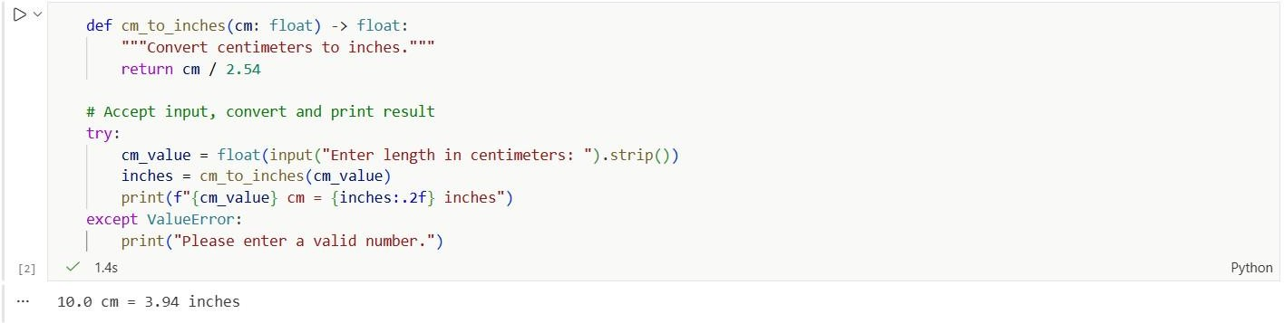

Task-3 :Few-Shot Prompting – Name Formatting Scenario
Few-shot prompting improves accuracy by providing multiple examples.
Prompt : Format a person's full name into the format "Last, First" using Python.
Examples:
Input: John Smith Output: Smith, John Input: Anita Rao Output: Rao, Anita Input: Rahul Verma Output: Verma, Rahul
Now generate a Python Code that:
- Accepts a full name as input
- Formats the name as "Last, First"
- Returns the formatted name
- Includes sample inputs and outputs

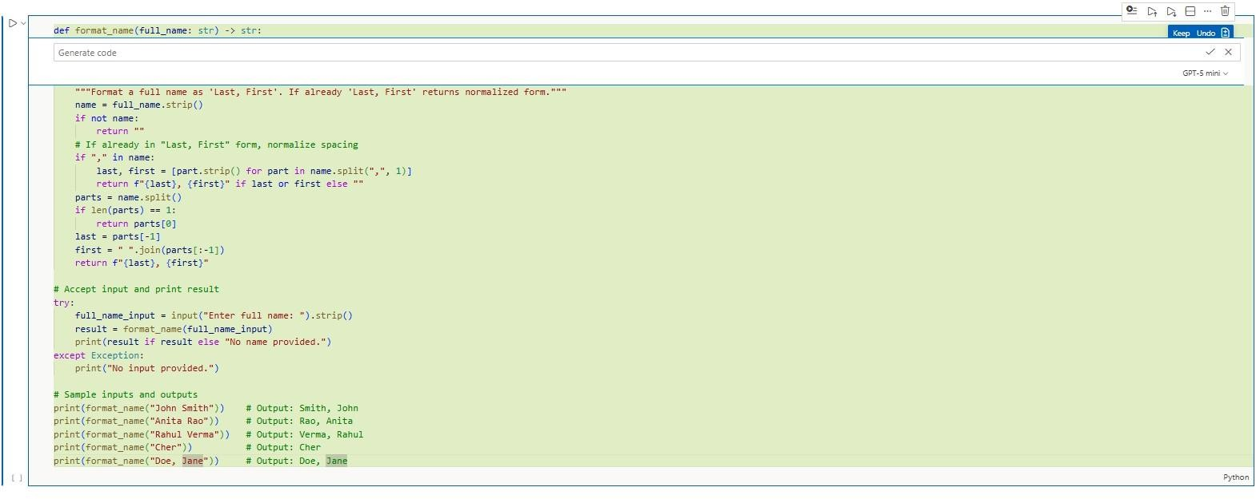

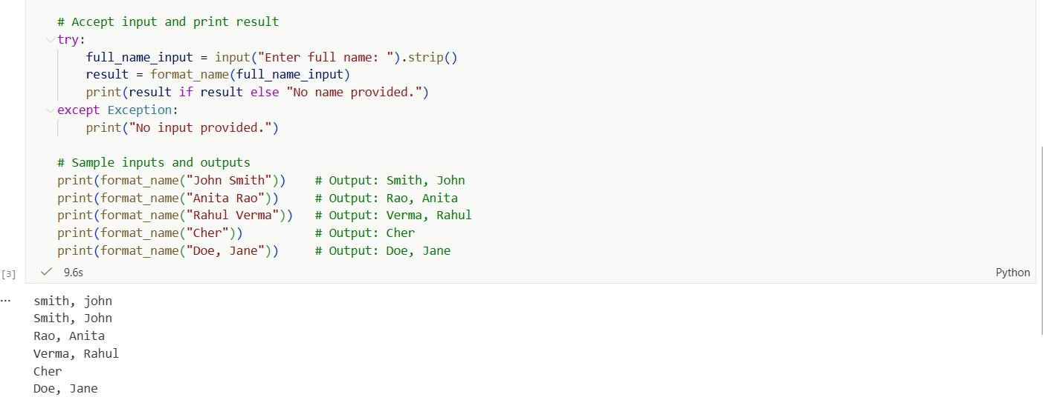
Output -

Task-4 : Comparative Analysis – Zero-Shot vs Few-Shot Scenario
Different prompt strategies may produce different code quality.
Prompt : 1. Generate a Python Code that accepts a string as input and counts the number of vowels in the string.
The function should return the total vowel count. Also include a sample input and output.
2.Count the number of vowels in a string using Python. Examples:
Input: "hello" Output: 2

Input: "Education" Output: 5
Input: "sky" Output: 0
Now generate a Python Code that:
- Accepts a string as input
- Counts the number of vowels in the string
- Returns the total count
- Includes sample inputs and outputs
3.Compare the zero-shot and few-shot vowel counting functions based on accuracy, readability, and logical clarity.
Present the comparison in a table or a short reflection paragraph. Conclude which prompting technique is more effective and why.
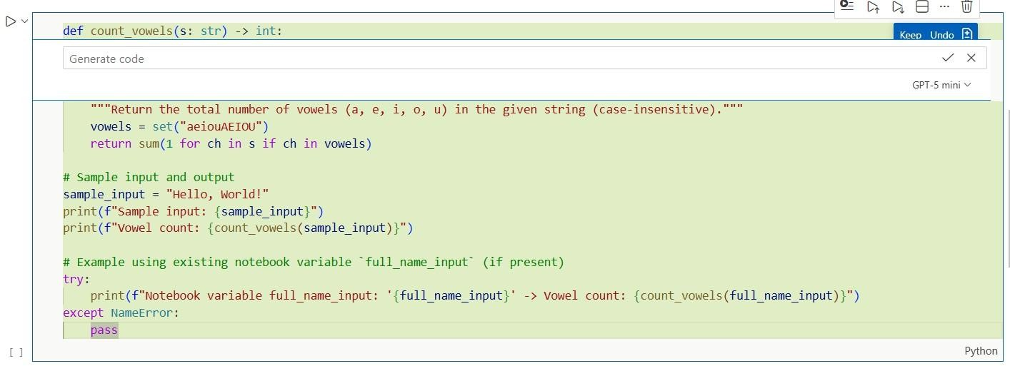
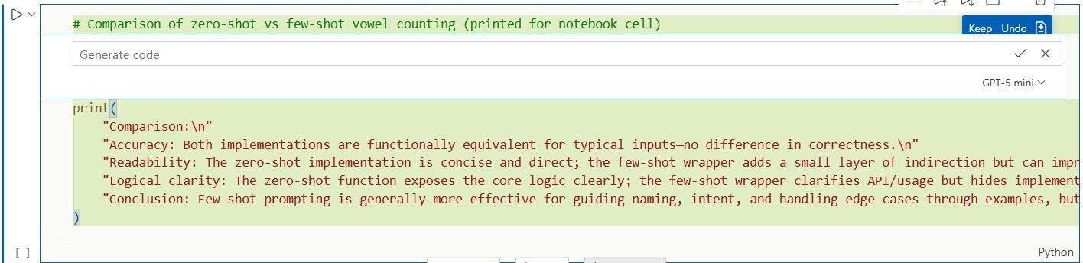
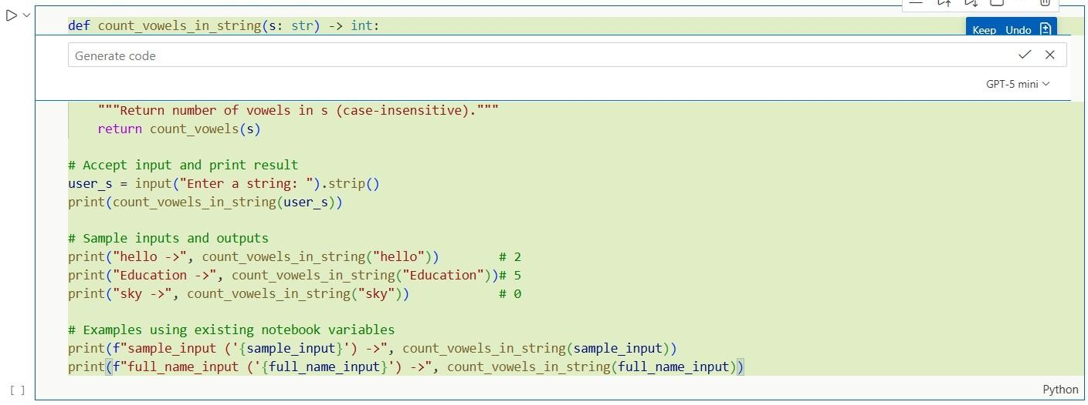

Output-
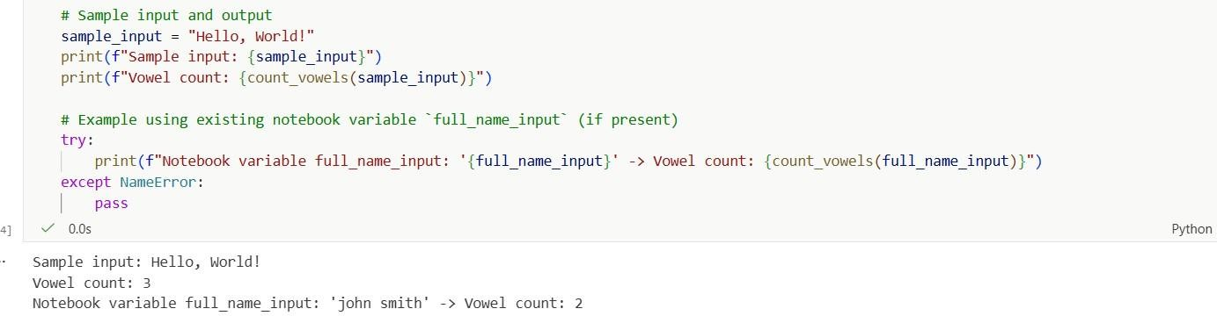
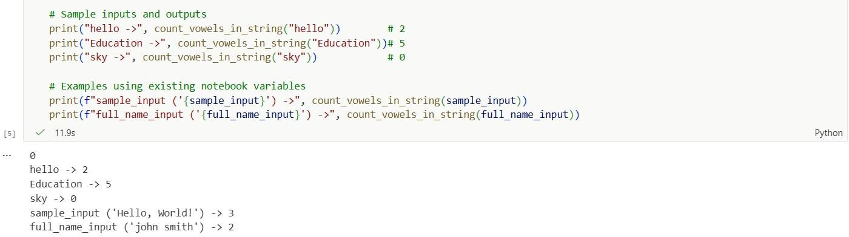

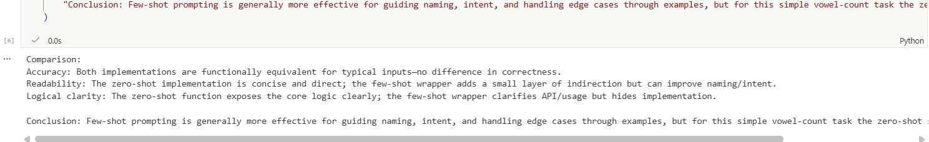
Task-5 : Few-Shot Prompting – File Handling Scenario File processing requires clear logical understanding.
Prompt : Read a text file and count the number of lines using Python. Examples:
Example 1:
File content:
Hello
Welcome to Python File handling is easy Output:

Number of lines: 3 Example 2:
File content:
AI
Prompt Engineering
Fewshot Learning Output:
Number of lines: 3
Now generate a Python Code that:
- Reads a .txt file given its filename
- Counts the total number of lines in the file
- Returns the line count
- Includes a sample .txt file input and its output
- Explains the logic used in the function

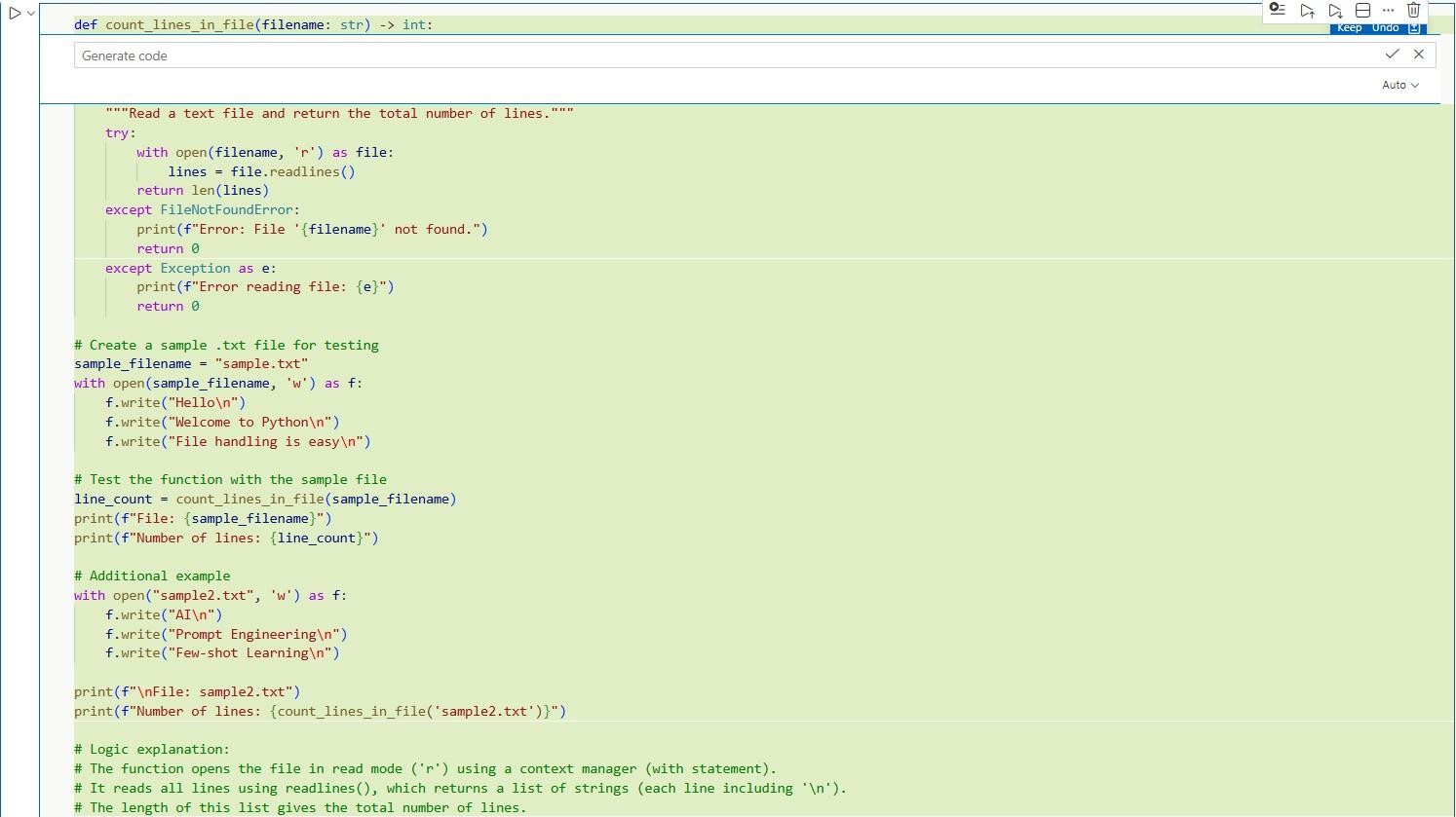

Output -

